**NAAN MUDHALVAN**

**DIGITAL MARKETING**

**Participants:**

AU913120104033 – S R Harshitha

AU913120104056 – K B Monisha

AU913120104078 – D Rubavathy

AU913117104085 – G Shanthi

**PROJECT – 2**

**Social Media Campaign**

**Create a social media ad campaign in Facebook**

# Aim:

To create an social media ad campaign in facebook.

# Procedure:

**Industry Selection:**

* Research and identify the target audience and niche within the industry. Consider factors like gender, age group, sports focus, or unique selling points.
* Choose a brand name that resonates with your niche, is easy to remember, and has an available domain name for a future website

# Creating an Email ID:

* Select an email service provider like Gmail, Yahoo, or Outlook.
* 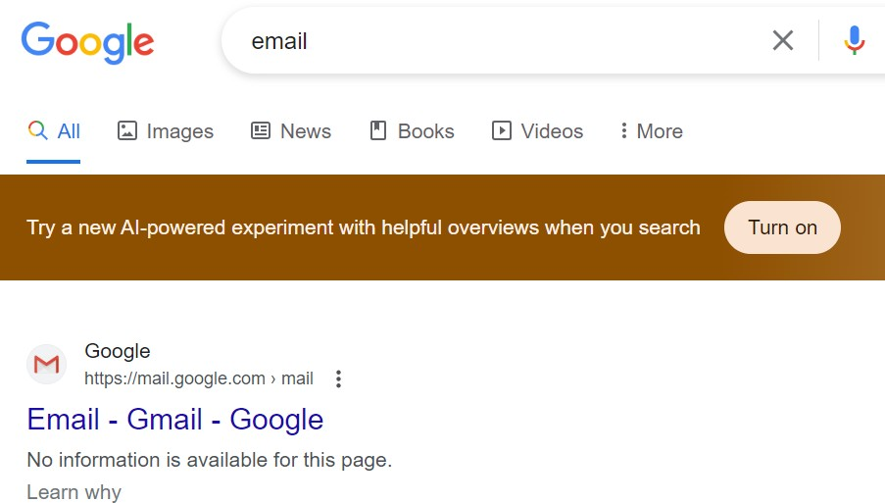Visit the chosen provider's website.
* Click on "Sign Up" or "Create Account."

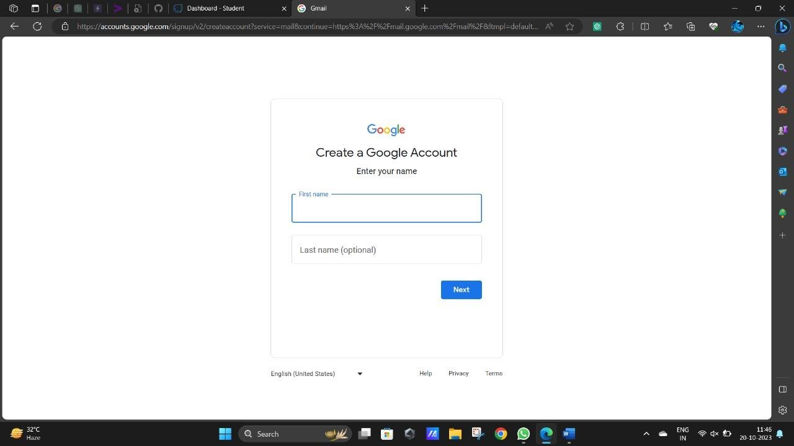

* Fill in your personal information, including your name and preferred email address.

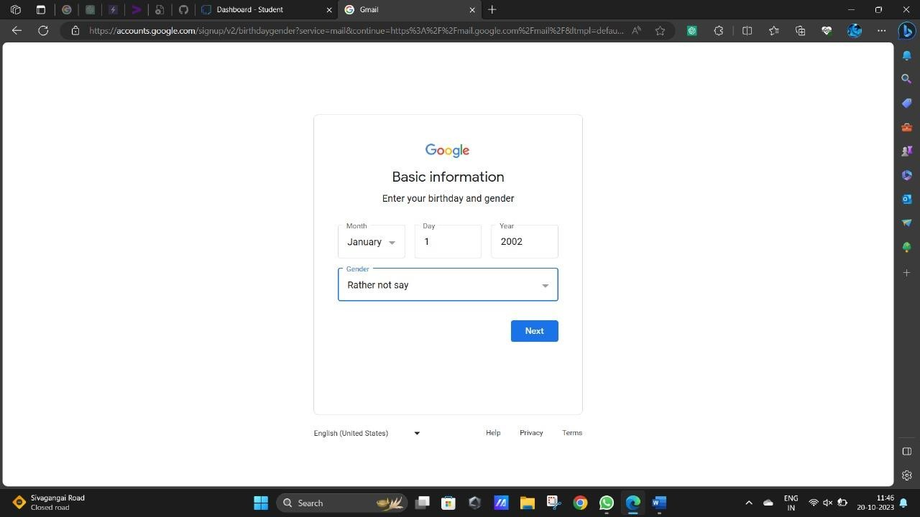

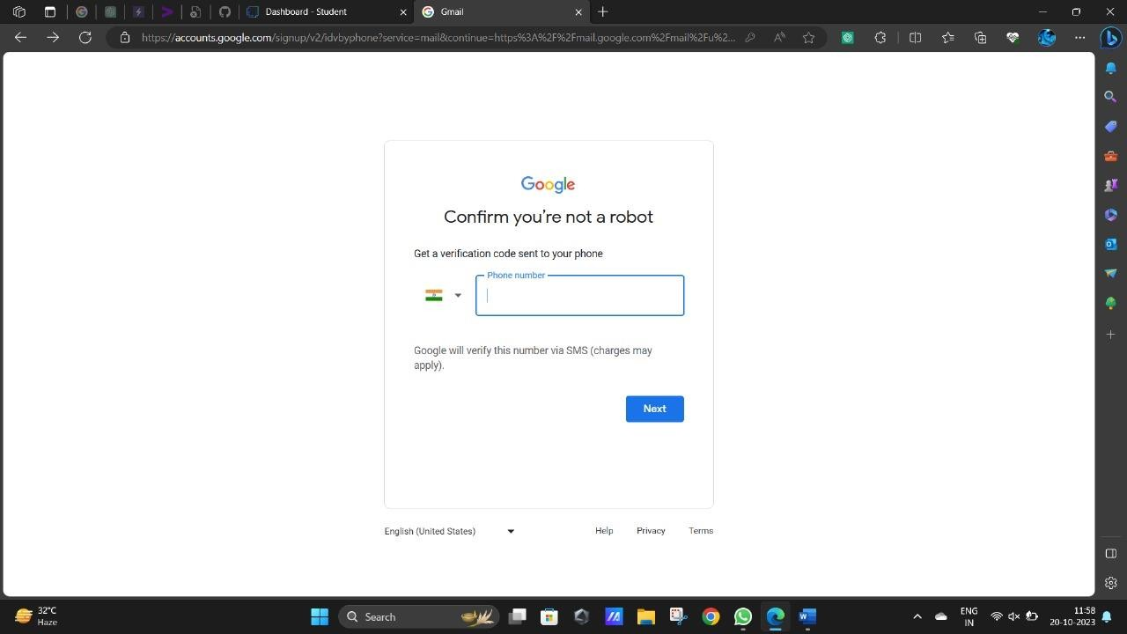

* Set a secure password.
* Verify your identity through a verification code sent to your phone or another email address.

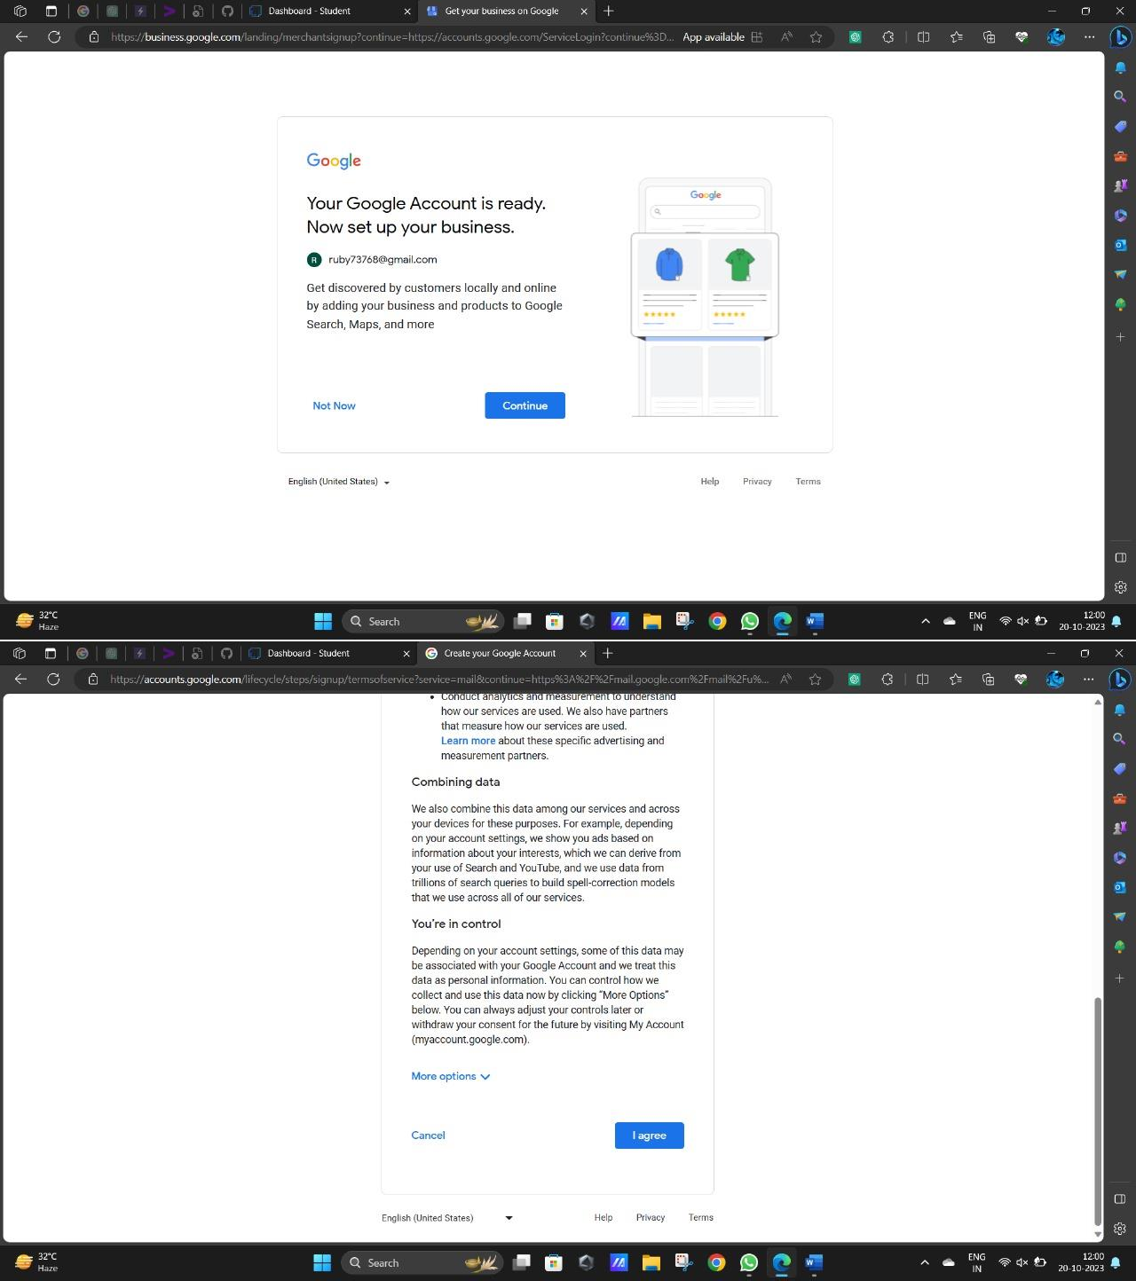

* Your email account is now created.

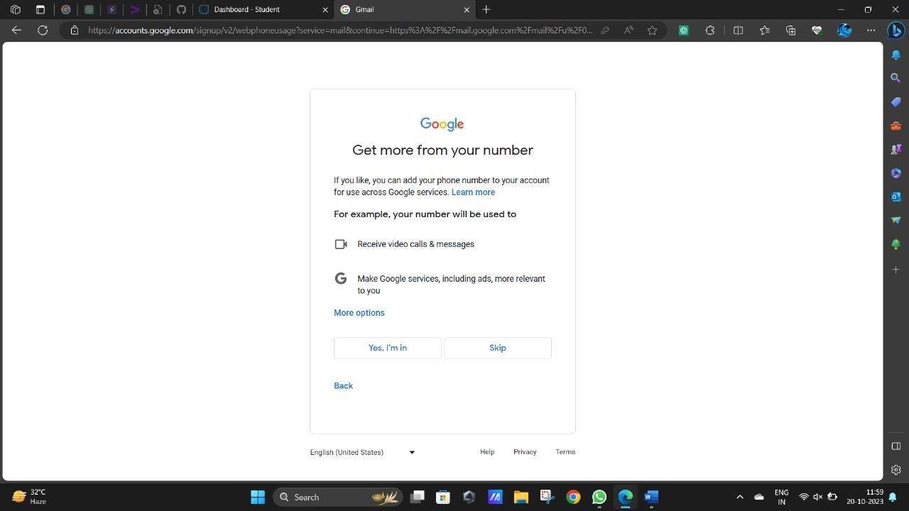

# Designing a Logo

* Create a logo that reflects the brand's identity, values, and target audience.
* Choose a color palette that aligns with your brand and industry.
* Ensure the logo is versatile and looks good in various sizes and formats.

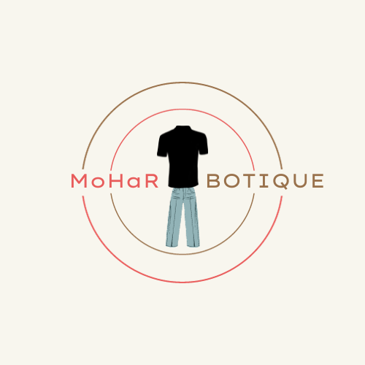

# Creating an Facebook Page

* Download the Facebook app from your smartphone's app store.
* Open the app/website.

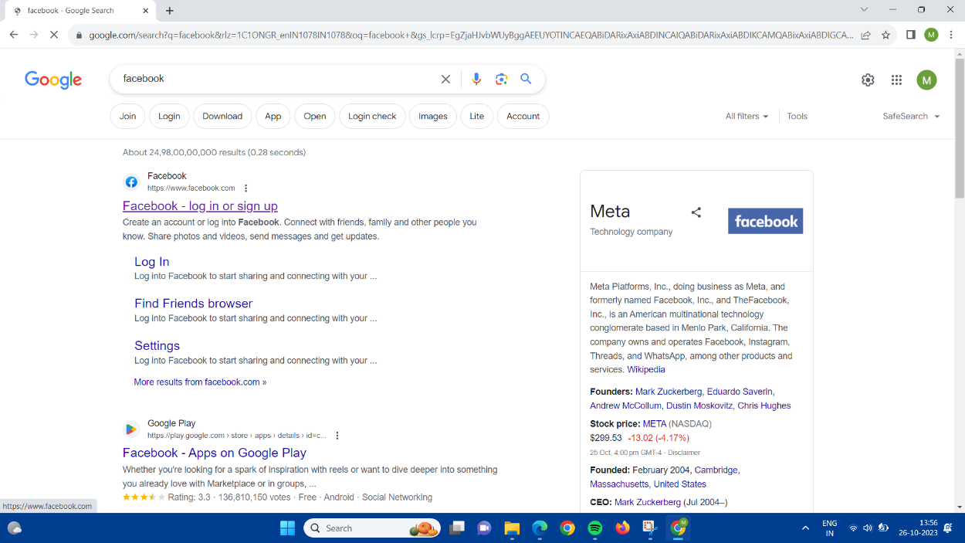

* Sign up for a new account using your brand's name, a profile picture (use your logo), and a bio that describes your brand.

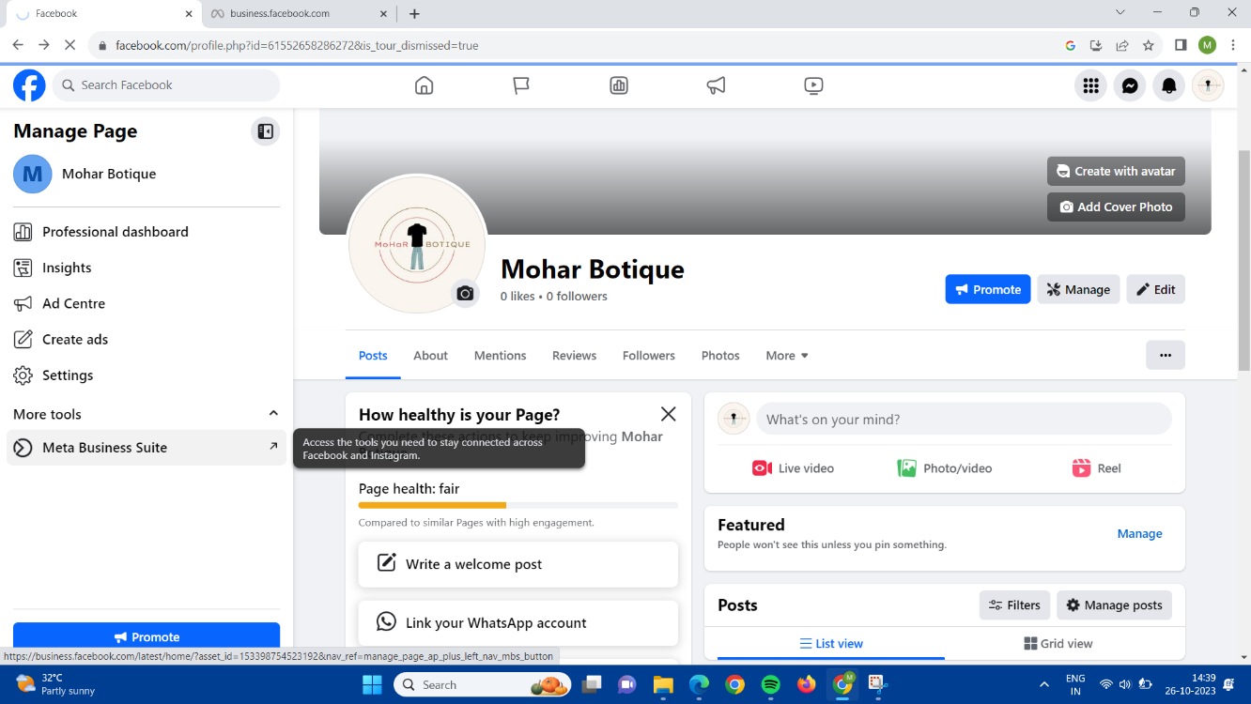

# Creating an Ad:

Open Meta Business Suite

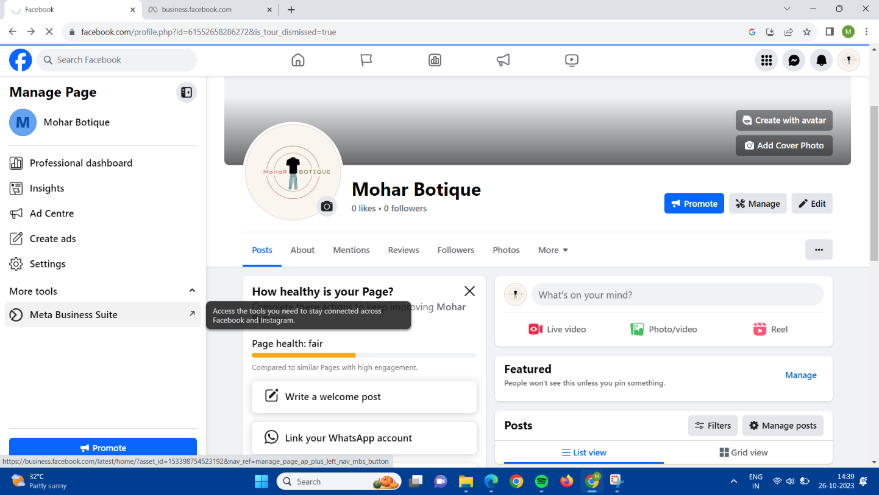

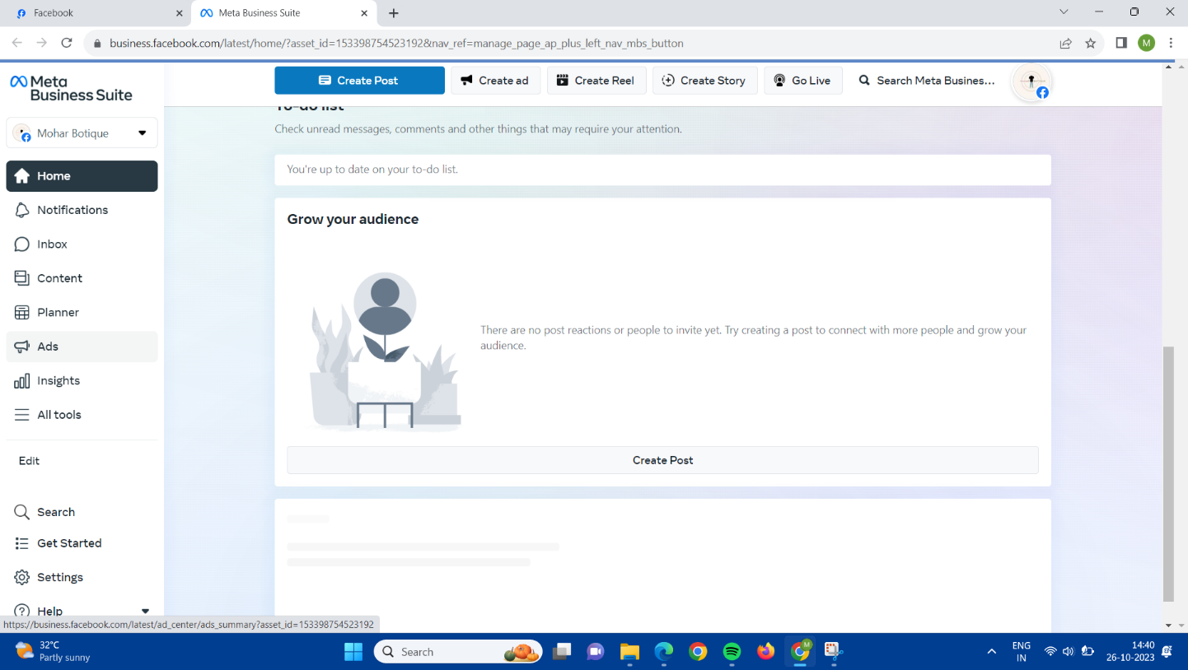

Go to ads and click create add and set the goal as to get more leads

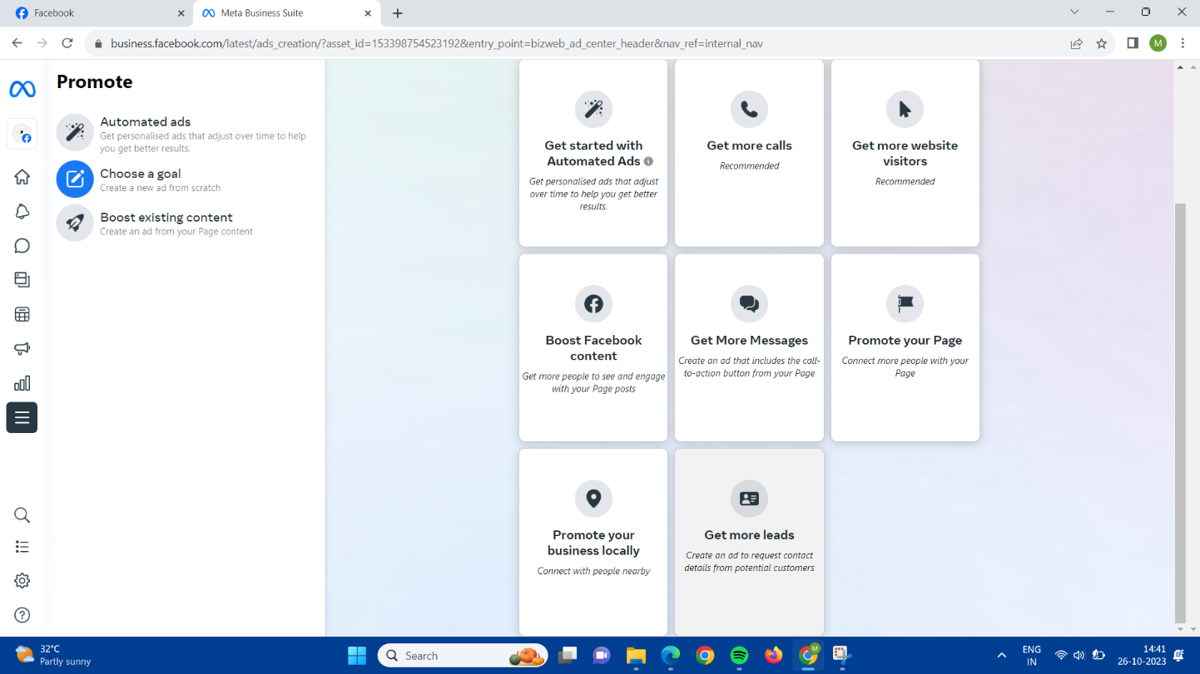

Then fill all the details 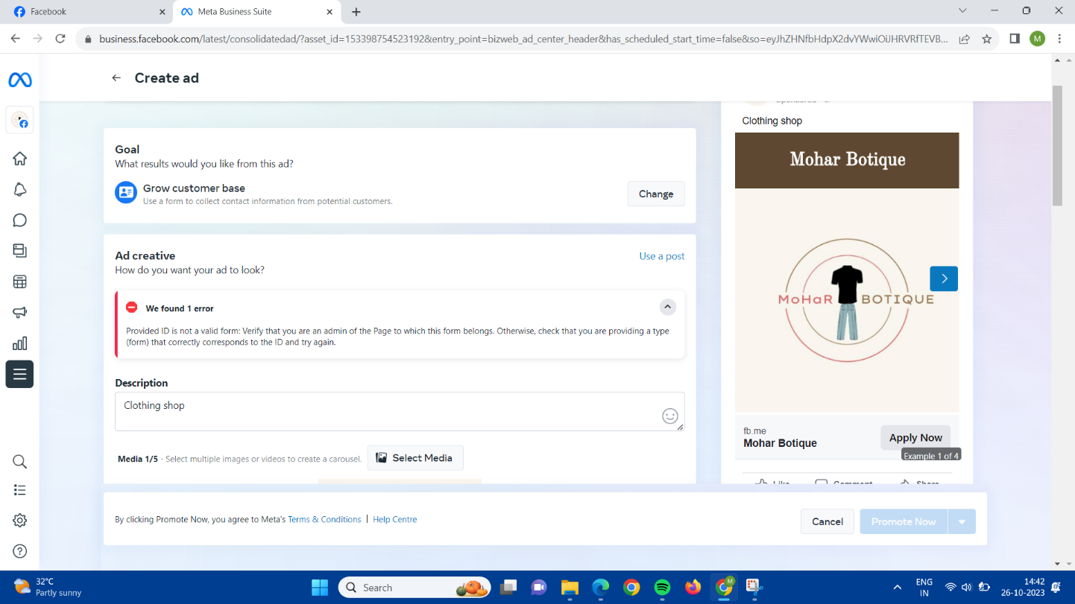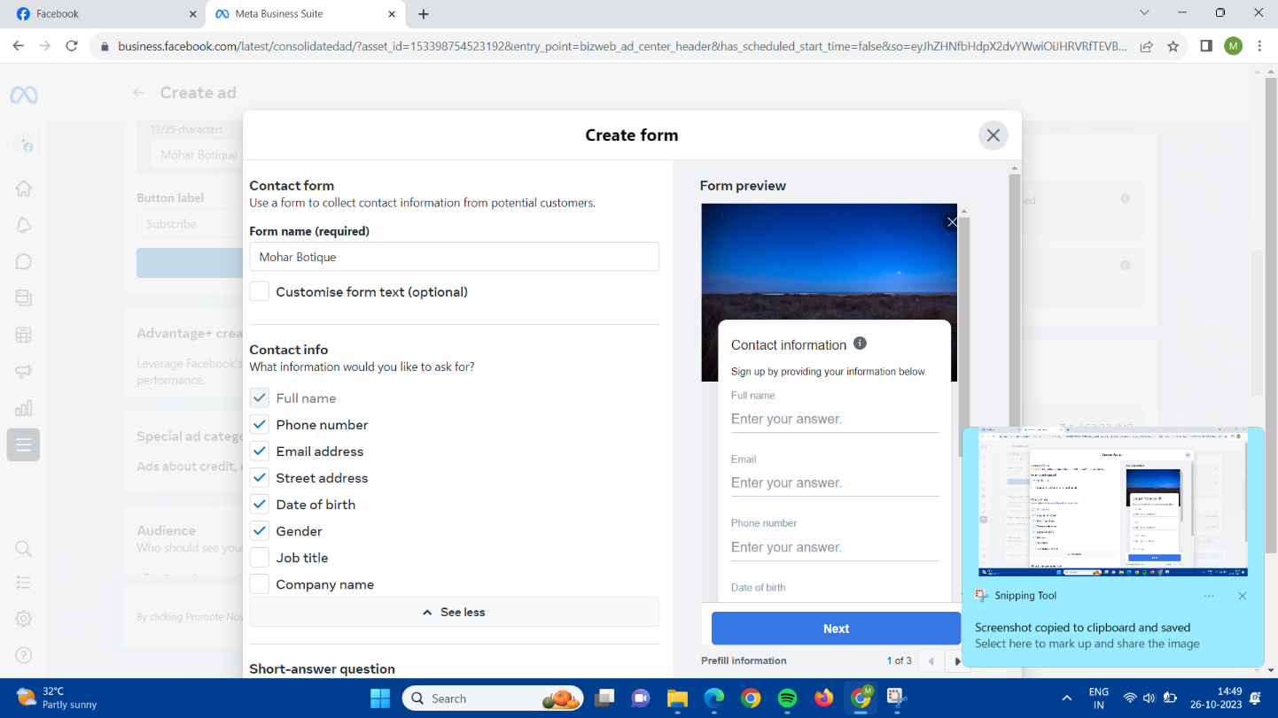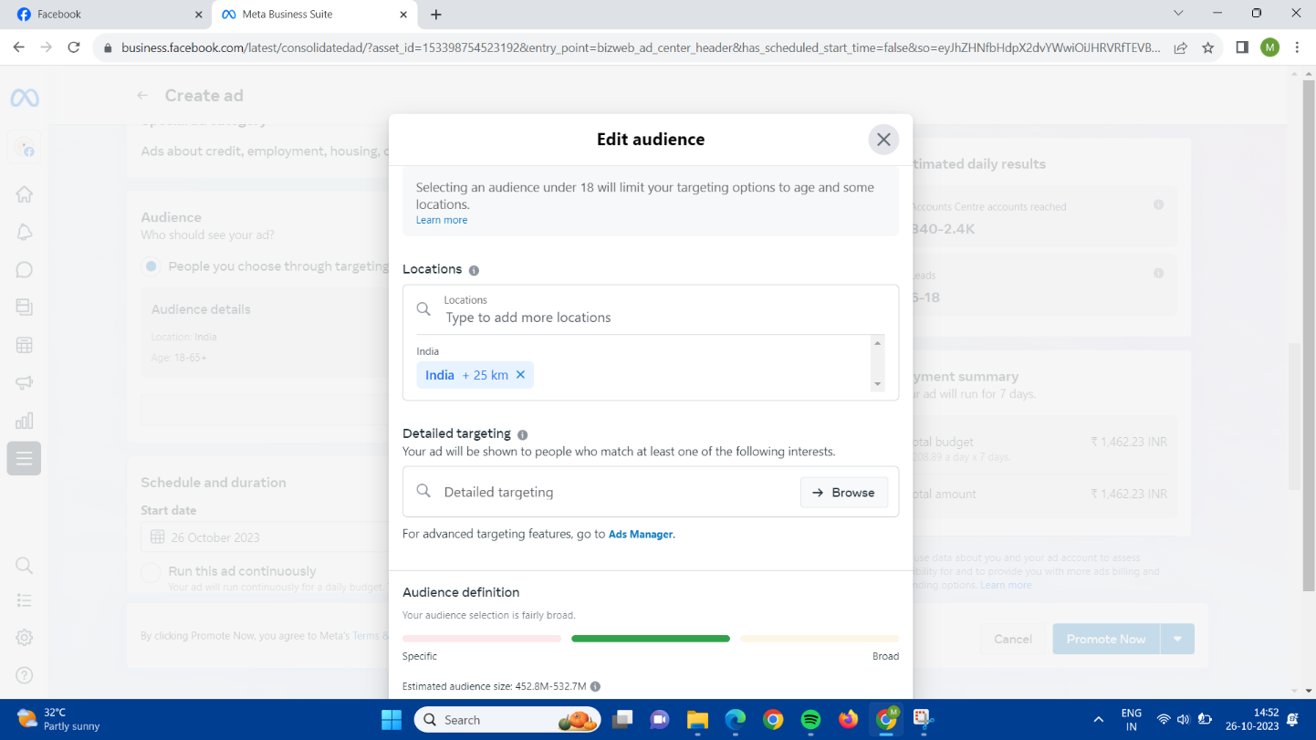

After filling the details and payment process, the ad is posted in the facebook

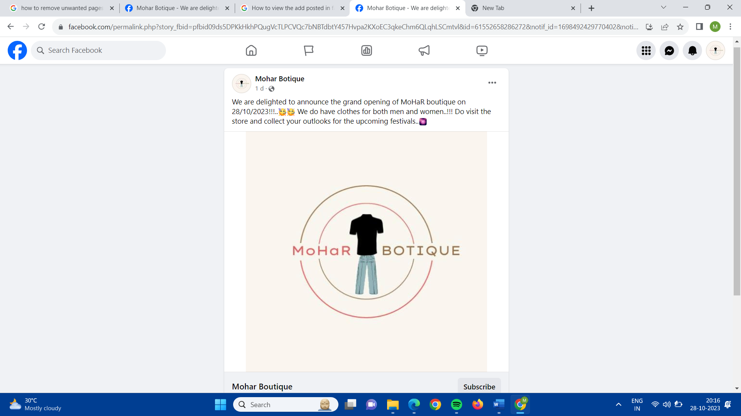

**Result**:

# Email Id:

[moharbotique@gmail.com](mailto:moharbotique@gmail.com)

# Industry Name:

MoHar Boutique

# Industry Type:

Clothing shop

# Facebook page:

## Mohar Botique

# <https://www.facebook.com/profile.php?id=61552658286272>

# Facebook Ad:

# <https://www.facebook.com/permalink.php?story_fbid=pfbid09ds5DPKkHkhPQugVcTLPCVQc7bNBTdbtY457Hvpa2KXoEC3qkeChm6QLqhLSCmtvl&id=61552658286272&notif_id=1698492429770402&notif_t=feedback_reaction_generic&ref=notif>

# Canva Logo:

# <https://www.canva.com/design/DAFyQA6GOps/vNCU1MGE_2rA5mCqn6yeag/edit?utm_content=DAFyQA6GOps&utm_campaign=designshare&utm_medium=link2&utm_source=sharebutton>

* **Youtube link:**

<https://www.youtube.com/watch?v=mVEPnAn03as&t=8s>